Tugas Manajemen Basis Data

Transaction

Query Create Table

CREATE TABLE Account(

    ID SERIAL NOT NULL PRIMARY KEY,

    NAME VARCHAR(50) NOT NULL,

    BALANCE INTEGER NOT NULL,

    LAST_UPDATE TIMESTAMP DEFAULT NOW() NOT NULL

)

Query Input Data

INSERT INTO Account (NAME,BALANCE) VALUES

('Jasmine',1500000),

('Ariel',500000),

('Belle',300000)

**Non-Repeatable Reads**

1. Read Committed
2. Repeatable Read

1. Serializable

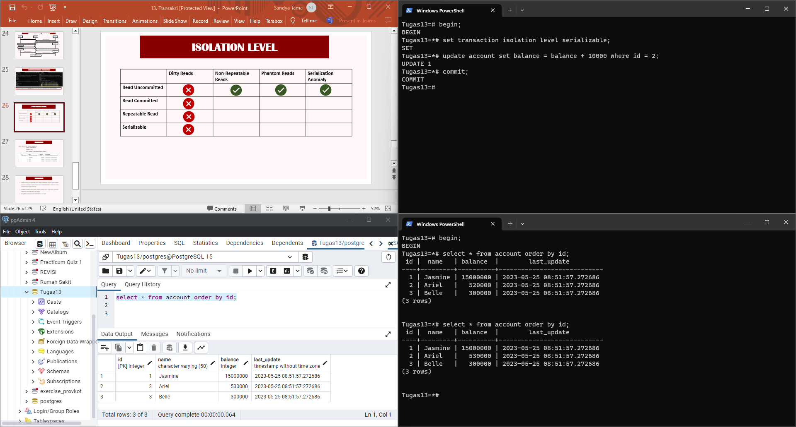

**Phantom Reads**

1. Read Committed
2. Repeatable Read
3. Serilizable